**SQL-STRUCTURED QUERY LANGUAGE**

SHOW DATABASES: shows the databases.

USE DATABASE: tells to use the named database as the default.

CREATE TABLE: specify the layout of your table.

VARCHAR, INTEGER: data type used for storing text.

DESC: (DESCRIBE) to show the structure of table.

PRIMARY KEY: is a single field that uniquely defines a record.

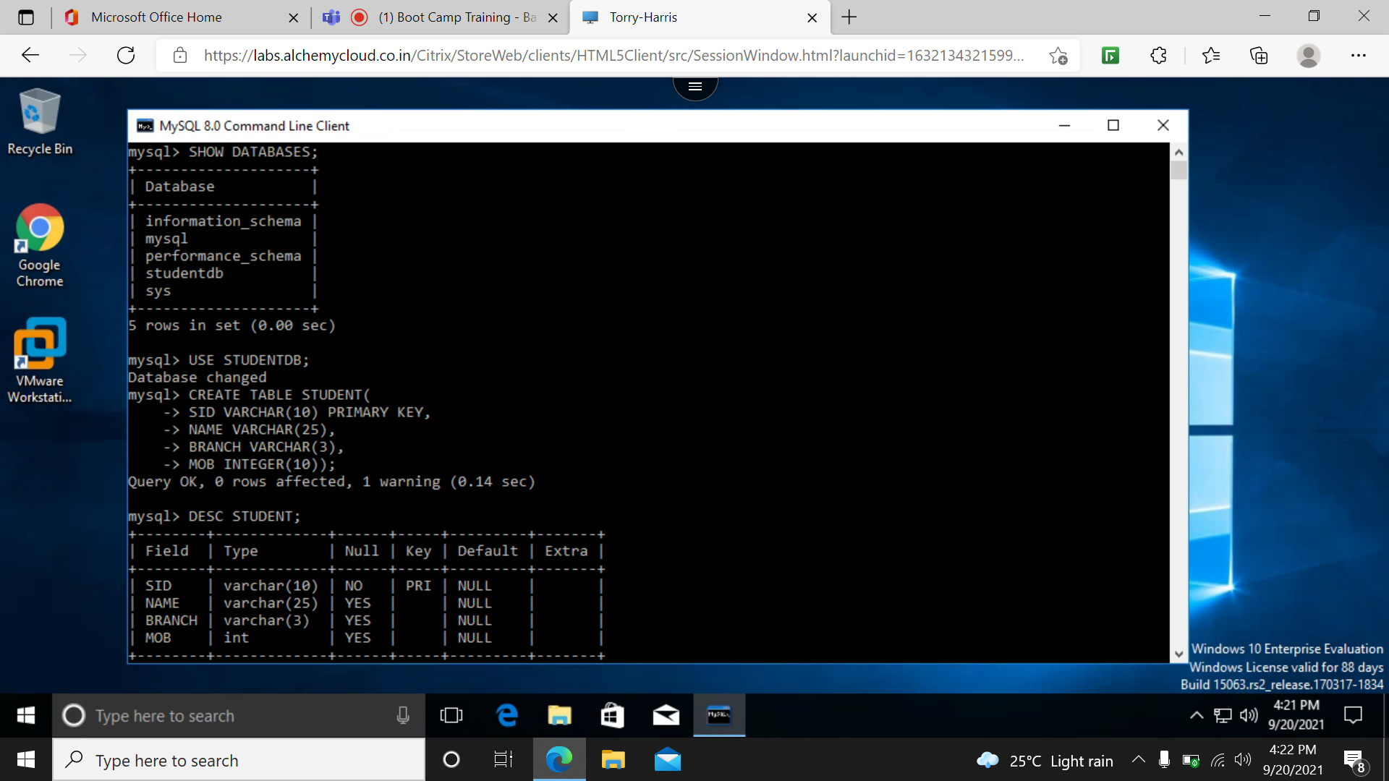

INSERT VALUES: insert data into the table.

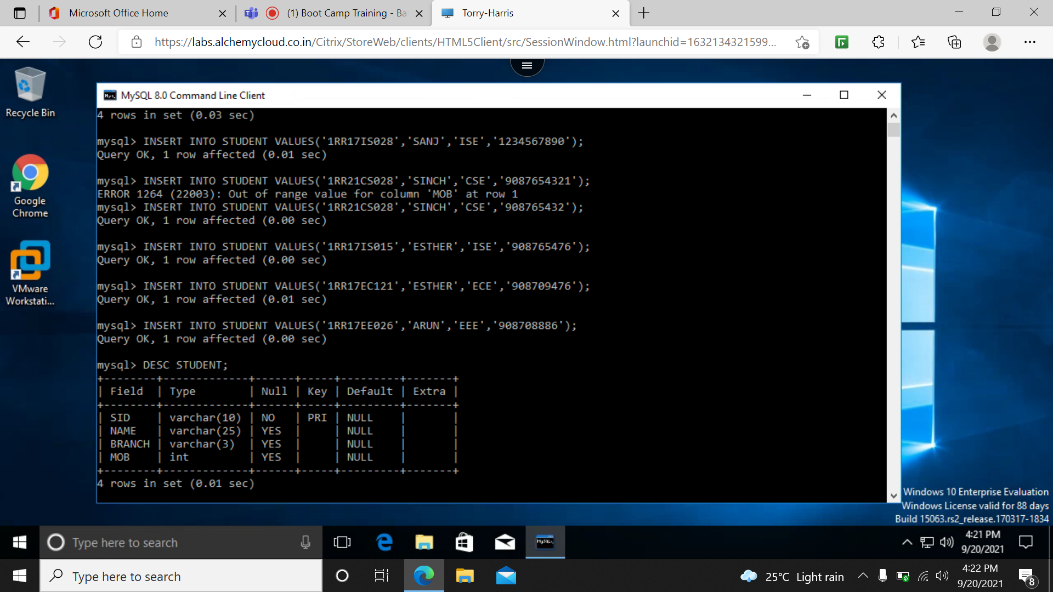

SHOW TABLE: shows the tables

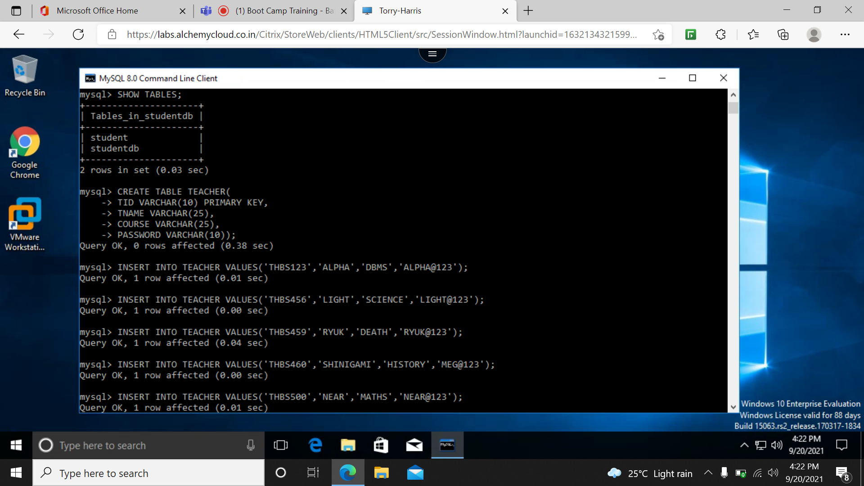

SECLECT * FROM TEACHER: show the contents of the table.

